**3W Performance Monitoring (3W PM)**

**User Guide**

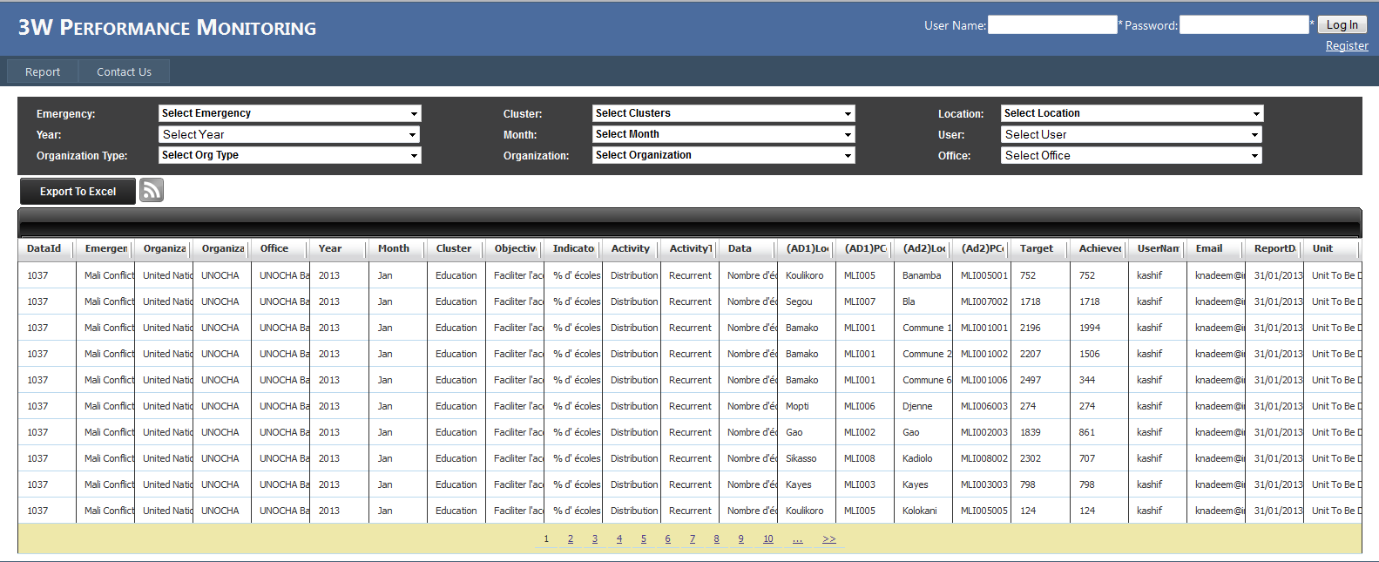

3W Performance Monitoring (3WPM) is a web based tool. It has been developed as a reporting tool for all the stakeholders to report their activities and share inter organization and intra organization information. There is also an Excel dashboard which can be used to extract information from the data entered in this tool. Excel dashboard has charts, maps and summary information on the basis of data entered in 3WPM.

This tool is very simple and only has three pages, after registration, to view and enter data. The simple design of this tool makes is easy for any user who has a little knowledge of computer to enter data into 3WPM.

To View data user don’t have to login and the home page will show all the data in this online database. User can use different criteria to filter data. The data on the page can be export to Excel and there is also a link to fetch all data as an XML feed.

The user wants to report using this tool has to register first. After successfully login user will see two pages, ‘My Activities’ and ‘Data Entry’ using these two pages user can enter her/his 3W information into 3WPM.

**Details of home page: The detail of each tag in image is given below**

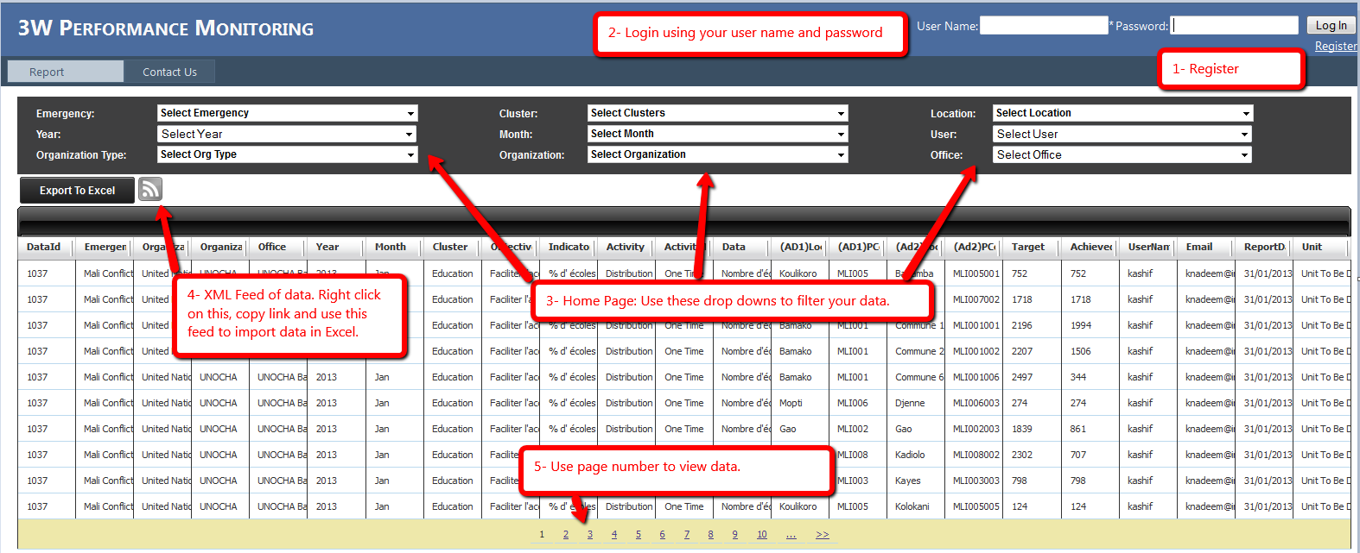

1. **Register:** Click on Register link to register yourself. You will see a very straight forward page. Fields on this page are :
   1. User Name: Enter your user name. If someone already has that username then you will see a message.
   2. Password: Password should be at least 3 characters.
   3. Confirm Password: Repeat your password again to confirm.
   4. Email: Enter your valid email address. This address will be used for correspondence.
   5. Phone: Enter your phone/cell number.
   6. Organization: Select your organization from the list. If you organization is not in the list please contact us by using ‘Contact Us’ page, email and/or phone to add your organization.
   7. Office Country: Select your office country from locations list. If country in which your office resides does not exist in list please contact us.

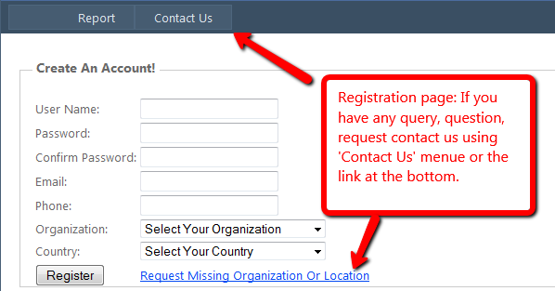

1. **Login:** Use user-name and password to login. If you don’t have account please click on ‘Register’ link to register yourself.
2. **Filter Data:** User can filter data using drop down on top of the page. In most of the drop downs user can select multiple values like in the following image. In following image use selected three clusters to filter there data.

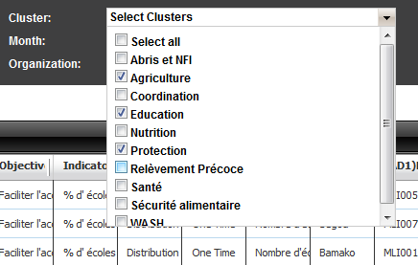

User can filter data on Emergency, Cluster, Location, Year, Month, User, Organization Type, Organization and Office. User can filter data on multiple criteria like Cluster and Location etc.

1. **XML Feed Link:** This is very important feature of this tool. This link is to fetch all the data, after filter criteria applied, will be fetched as an XML feed. You can use this xml feed where ever you want but in this tool this feed is especially being generated for the data feed of Excel Dashboard.

User can get the URL of this feed two ways 1) click on this button and it will open a new page, copy URL from browsers address bar. 2) Right click on this button and copy link location. After getting this URL user can use this URL anywhere s/he wants to.

To use this in Excel as data feed, please follow these steps.

* 1. Get URL of the feed: We have described above two ways to get URL of this feed.
  2. Open Excel.
  3. Click on menu Data -> From Other Sources -> From XML Data Import

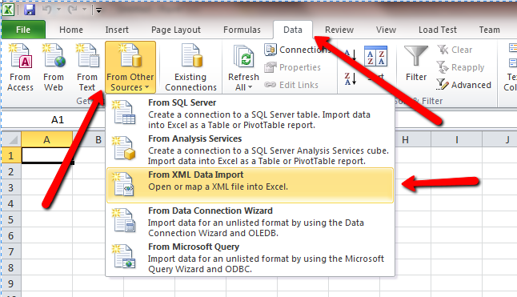

* 1. Paste copied URL in ‘File Name’ box and click Open, see following image.

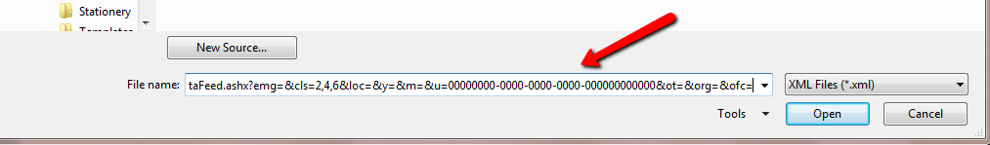

* 1. You might see few message but just click ‘Yes’ Or ‘OK’.
  2. You can get latest data just by clicking on ‘Refresh’ button in Excel without going back to 3WPM tool and doing the same exercise again.

1. **Export To Excel:**  You can export this data to excel by clicking on ‘Export To Excel’ button. All your filtered data will be exported to an Excel Sheet.

**Contact US:** Use contact us page to send your feedback, questions, requests and queries.

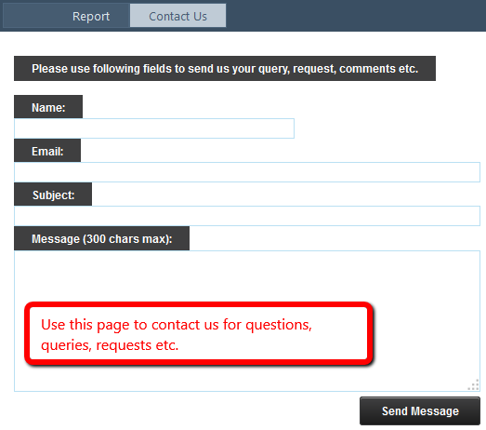

After login user will see two new pages. These two pages are interrelated. User has to use both these to report his/her 3W activities.

**My Activities Page:** This is the page from where user will select his/her activitis on which s/he wants to report. This is very simple page. Following is the image and explanation of each item on the page.

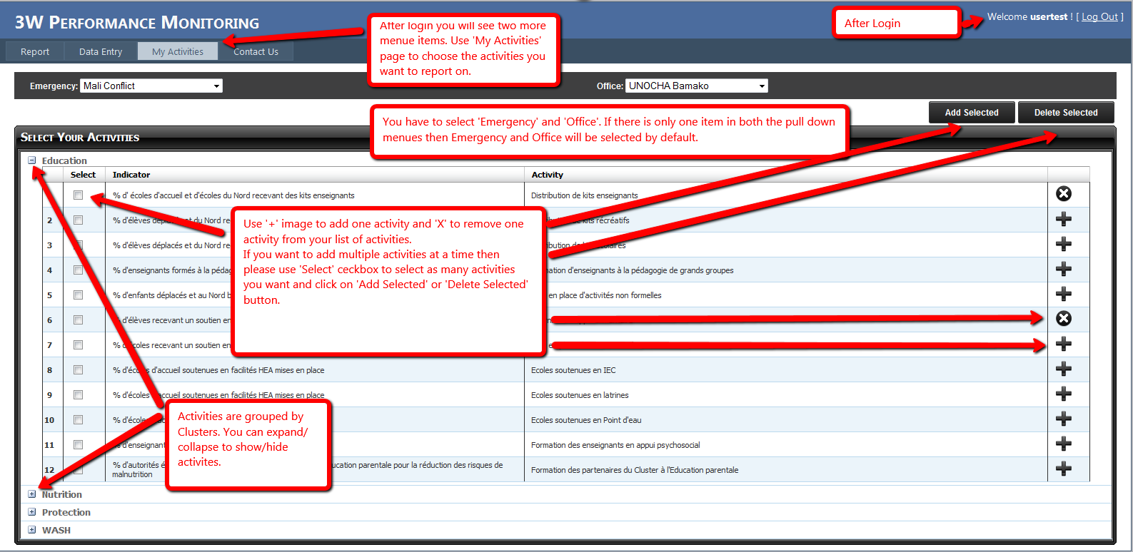

On this page user will see two drop downs i.e. ‘Emergency’ & ‘Office’. Emergency drop down will have all the emergencies of that country which user has selected at the time of registration. Office drop down will have all the emergencies of that country which user has selected at time of registration.

If there is only one emergency and only one office then both these will be selected by default otherwise user has to select his/her emergency and office from respective drop downs.

There is one grid on this page with heading ‘My Activities’. This grid has all the activities grouped by clusters. User can expand/collapse these clusters.

Add/Remove Activities: If user want to add one activity at a time then there is ‘+’ icon on right of the activity, clicking this icon will add activity in user’s list. If user want to remove an activity from his/her list user just have to click on ‘X’ icon.

User can also add/remove multiple activities at a time. To do this user has to use ‘Select’ checkbox in first column of the grid, at left side, and select as many activities as s/he wants from different clusters. After selecting activities click on ‘Add Selected’ button on top-right of the page to add activities and click on ‘Delete Selected’ button to remove activities from his/her list.

User can see his/her selected activities in ‘Data Entry’.

**Data Entry Page:**

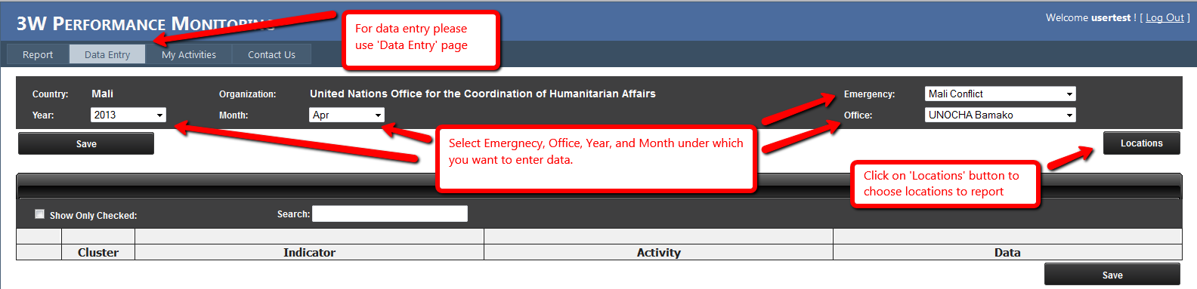

User can enter target and achieved data against their activities in this page. The details of this page are following:

1. **Emergency:** This is a pull down box having all the emergencies of user’s location. If there is only one emergency then it will be automatically selected but if there is more than one then user has to select the emergency under which s/he wants to report.
2. **Office:** This is a pull down box having all the offices of user’s organization. If there is more than one office then user has to select his/her office. If there is only one office then it will be selected automatically.
3. **Year:** This pull down box having years list. Current year will be selected automatically but user can select any other year.
4. **Month:** This pull down box having month names. Current month will be selected automatically but user can select any other month.
5. **Locations (Button):** When user will click this button a window will pop-up. This window will have all the list of admin2 locations of user’s admin1 location in left side of the box. User can select one or more than one locations on which s/he wants to report in that particular emergency/year/month.

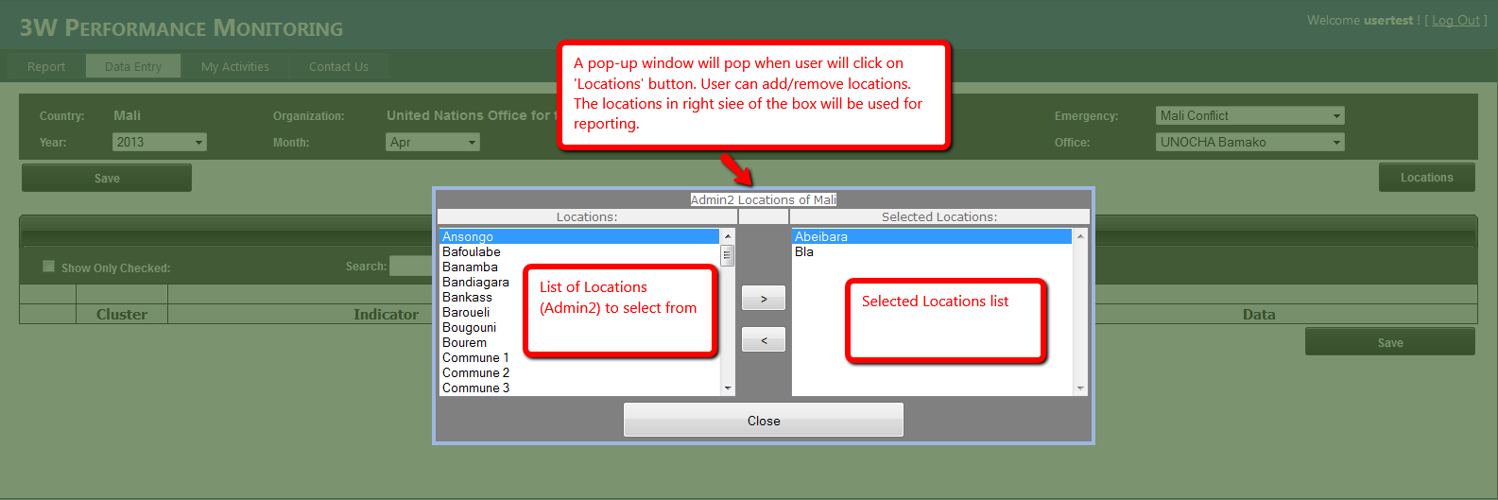

After selecting locations user can report on the activities.

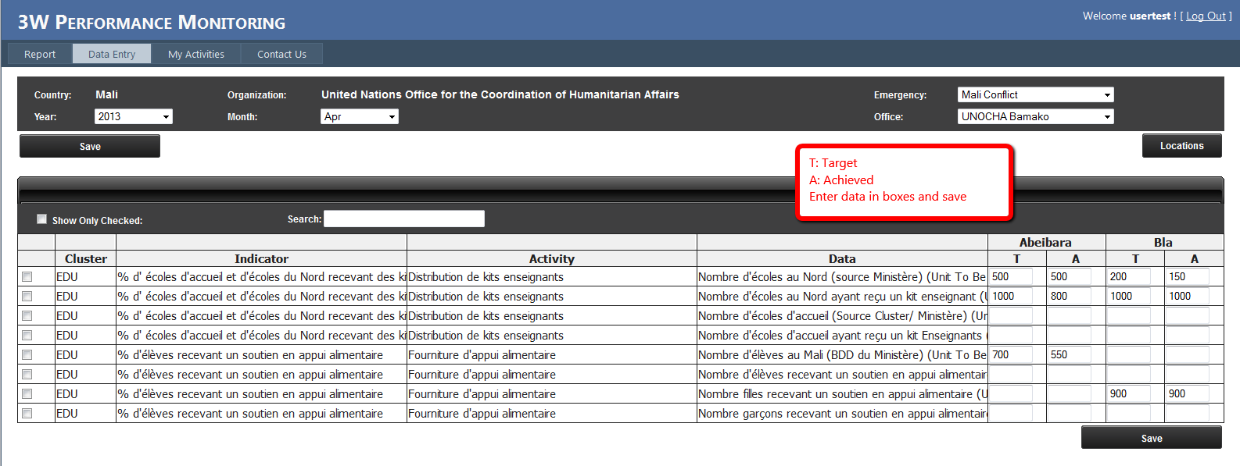

User can enter targets and achieved for an activity under locations and save. User can also add more locations and remove already added locations in the report. If user removes a location and click on save button the data of removed locations deleted permanently.